
Bathford Church School Pupil Premium Strategy Statement 2023-2024
This statement details our school’s use of pupil premium (and recovery premium for the 2022 to 2023 academic year) funding to help improve the attainment of our disadvantaged pupils. It outlines our pupil premium strategy, how we intend to spend the funding in this academic year and the effect that last year’s spending of pupil premium had within our school. Our funding allocation will focus on three core areas:
- Teaching
- Targeted academic support
- Wider strategies

Our approaches will be monitored and reviewed to analyse impact on outcomes for disadvantaged pupils.




School overview
Total number of pupils in school | 7/171
Proportion of disadvantaged pupils | 4.09%
Proportion of disadvantaged pupils who have SEND | 3/7 42.85% of PP Cohort
Academic year/years that our current pupil premium strategy plan covers (3 year plans are recommended) | 2023-2024
Publish date | December 2023
Review date | July 2024
Statement authorised by | B Hayter – Headteacher  C Hart– Vice Chair of Governors
Pupil Premium lead | Jennifer Keenan
Governor lead | Charlotte Hart
Funding Overview
Detail | Amount
Pupil premium funding allocation this academic year | £15724
Recovery premium funding allocation this academic year | £2000
Pupil premium funding carried forward from previous years (enter £0 if not applicable) | £0
Total budget for this academic year  If your school is an academy in a trust that pools this funding, state the amount available to your school this academic year | £17724

Part A: Pupil Premium Strategy Plan
Statement of Intent – Over 3 Years
Key principles of our strategy echo those of our school vision with a specific focus on children identified as disadvantaged:
We aim to help our children to grow by equipping them with the knowledge, skills and values they need both to make sense of the world and to become caring, responsible global citizens.
Key objectives linked to our vision:
- Teachers have high expectations, responding and adapting their teaching as necessary for children identified as disadvantaged, using quality first teaching strategies.
- Cognitive and Metacognitive Strategies: Teachers manage cognitive load in order to enable children to transfer new learning to long-term memory. Teachers activate prior knowledge, teach small steps and provide opportunities for children to plan, monitor and evaluate their own learning. Children are aware of their learning and know where to focus their efforts so that they make good progress.
- A rigorous and sequential approach to reading and spelling develops pupil knowledge and confidence. It ensures that pupil premium children gain the depth of knowledge needed to apply learning to varied contexts and access all learning opportunities across the curriculum with which they are presented.
- Children identified as disadvantaged have consistently positive attitudes to their education. Where children find it difficult to emotionally regulate, demonstrate resilience or lack confidence in their ability, appropriate intervention is provided. This has a positive impact on pupils’ attitudes to learning, attendance and academic progress.
Challenges

This details the key challenges to achievement that we have identified among our disadvantaged pupils.
Challenge | Detail of challenge
1 | Many children on the Pupil Premium register do not have a strong view of themselves as learners and their role in the school community. There are opportunities for children identified as Pupil Premium to take on more roles, responsibilities and engage in the school’s extra curricular clubs which would support their wellbeing.
2 | Several children identified as Pupil Premium are not meeting age related expectations for reading (57.14% of PP not yet on track to meet ARE), which is impacting their ability to access their year group curriculum. (This group also includes pupils with SEND).
3 | Some pupils struggle in their confidence and resilience as mathematicians, which is reflected in attainment data (71.42% of PP not yet on track to meet ARE), therefore support is required to deepen their understanding of number.
4 | There are opportunities to develop improved information sharing resources on the school website and engage parents in the learning journey of their child so that they can best support targeted areas.
Intended Outcomes
This explains the outcomes we are aiming for by the end of our current strategy plan, and how we will measure whether they have been achieved.
Challenge | Intended outcome | Success criteria
1. | For children to have a positive view of themselves as learners in both academic opportunities and those beyond the national curriculum, knowing that they are important in the school community. | - Teachers share that children approach all learning with confidence and enthusiasm.  - Children have a good understanding of metacognition and their own particular learning methods.  - Children take part in a wider range of school activities including roles on school councils and leadership responsibilities.  - Identified children accessing identified support. Examples include:  - Thrive 1:1 support  - Brighter Futures  - CAMHs  - School Nurse  - Pupils are able to manage the transition to school with increasing confidence.  - There is an increase in the uptake for extra curricular opportunities.
2 | All pupil premium children will access high quality teaching of phonics and reading. Where needed this will include additional support/intervention to keep up or catch up. | - Children meeting the age-related expectation in phonics.  - Children making at least expected progress for reading.  - Pupil meet individualised learning targets (Pupil target plans).
3 | Children are engaged and make at least good progress in mathematics. They have the opportunity to take pleasure in and celebrate their successes. | - Assessment identifies pupil premium children who are not meeting their potential. (Pupil voice activities, book scrutinise and planning evidence, moderation)  - Children have a good understanding of metacognition and their own particular learning methods.  - Additional support is targeted, supporting small steps of progress.
4 | Families feel confident to support their children on their learning journey and know where to access the supporting information. | - Families engage positively with school support and take an active role in the learning journey.  - The school website and social media includes information based on parent feedback. This will show increased use or routes of support and strategies.  - The school will have developed more personalised information sharing in relation to strategies being used to support pupils (this could be a handout to explain a teaching method being shared, or an opportunity to view some of the intervention sessions).
Activity in this academic year 2023-2024
This details how we intend to spend our pupil premium (and recovery premium funding) this academic year to address the challenges listed above
Teaching (for example, CPD, recruitment and retention)
Budgeted Cost: £5300
Activity | Evidence that supports this approach | Challenge number(s) addressed
- Teachers explicitly teach children how their brains are wired for growth (growth mindset) using Class Dojo resources.  - Ensure explicitly teaching using metalanguage (subject specific language) as per teaching and learning policy and planning templates. | EEF evidence :  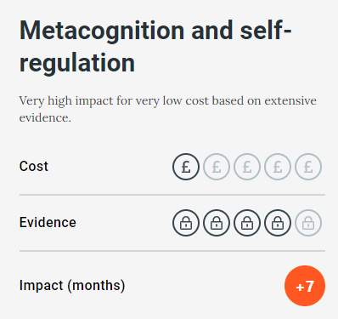 | 1,2,3,4
- CPD for teachers on metacognition using Walkthru (Metcognition and Self-regulation, Meta-cognitive talk), Third Space Learning The Primary School Guide to Metacognition and EEF Metacognition and self-regulated learning guidance report.  - CPD to include what is metacognition, why is it important, the benefits of metacognition in the classroom and how to teach metacognition through:  - Activating prior knowledge  - Giving explicit strategy instruction (e.g. use visual representations, bar models) model  - Consider consistent strategies to support children to reflect on their learning. E.g. potential use of weekly learning journals with weekly questions. What was easiest for me to learn this week? Why? What was most challenging for me to learn this week? Why? What learning strategies have worked well? What will I try to improve on for next week? | DfE guidance  EEF evidence :  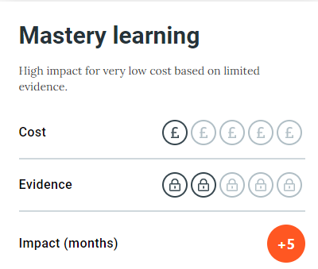 | 1,2,3,4
- Continue to embed and monitor the effectiveness of the Little Wandle Phonic Scheme.  - Colleagues to engage in intervention studies to allow the magic to spread and enhance consistency and use of most effective strategies. Teachers and Teaching assistants to sign up to be observed with focus on chosen aspect in relation to specific pupil needs e.g. small steps, modelling, scaffolding, checking for understanding, quizzing, guided practice, flexible grouping, explicit teaching of background knowledge/vocab etc  - Work with staff and parents to develop strategy sharing. | EEF evidence :  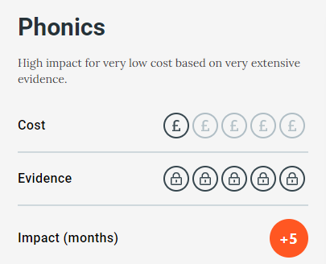  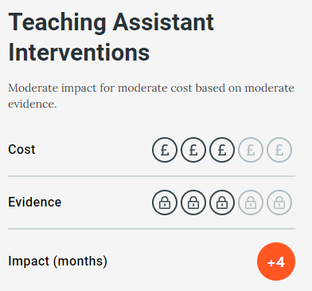 | 2,3,4
- Use RFP pedagogy https://ourfp.org/reading-for-pleasure-pedagogy/  to develop children’s RfP alongside and as complementary to reading instruction e.g:  - Develop social reading environments  - Daily read aloud from wide range of genres  - Informal book talk e.g. book blanket, book rivers, book blether  - Daily Independent reading time | EEF evidence : | 2
- Continue to engage with the Trust pupil premium leads in line with EEF training.  - Staff meetings (3 across the year) to disseminate training | EEF –Guide to the Pupil Premium ‘Good teaching is the most important lever schools have to improve outcomes for disadvantaged pupils.’ | 1,2,3,4

Targeted Academic Support (for example tutoring, one to one support, structured interventions)
Budgeted Cost: £10000
Activity | Evidence that supports this approach | Challenge number(s) addressed
- Provision map and interventions in place from Term 1  - Impact of interventions monitored and tracked  - Pupil progress meetings 3 times a year to discuss impact of interventions. | EEF evidence:  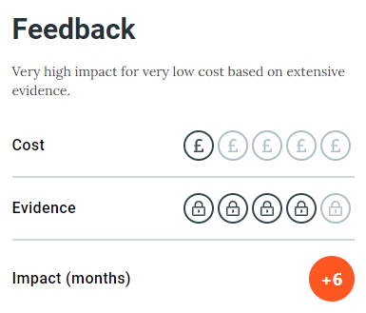 | 2,3
- Using phonics assessments, select pupils to receive a targeted, phonic programme.  - Deliver a series of parent support phonics/mathematics sessions to enable parent and child to learn together.  - Using reading assessments, select pupils to receive targeted reading intervention. This should include reading for pleasure which could be supported through the use of a therapy dog.  - Provide resources for this reading intervention and for children to take home.  - Deliver a series of parent support reading sessions to enable parent and child to learn together. | EEF evidence :  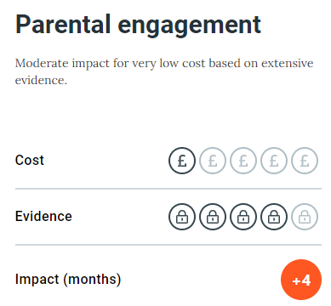 | 2,3,4
- Pupils to engage in maths tutoring with Third Space Learning where appropriate. | EEF Evidence:  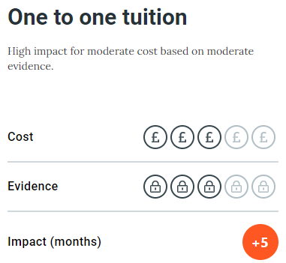 | 3

Wider Strategies (for example, related to behaviour, attendance, well-being)
Budgeted Cost: £2424
Activity | Evidence that supports this approach | Challenge number(s) addressed
- Termly tracking of attendance – triangulate this with other knowledge of families  - Information in Newsletter to all families about the importance of attendance and how quickly small frequent lateness or absences mount up  - Work with external agencies involved to support families to improve attendance and transition to school. | EEF evidence : | 4
- Map out our therapeutic and holistic interventions and support pathways and the criteria/thresholds needed for pupils and families to access this support.  - Embed the use of Thrive strategies activities across all year groups to support emotional regulation. This will be achieved through the Thrive Awards.  - Continue voice of the child activities  - Work with teachers to ensure a calm, consistent and fair, trauma informed approach  - Set up parent workshops on emotional regulation including how to manage meltdowns and outbursts and how to support siblings with additional needs. | EEF evidence:  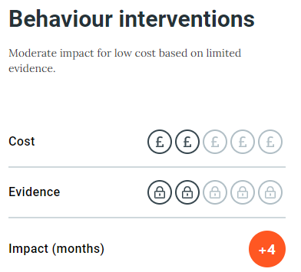  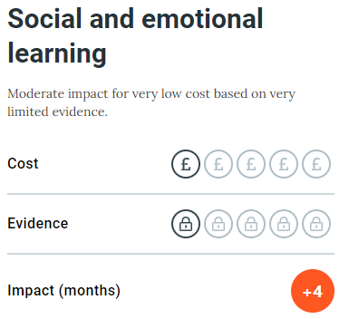  Body of research from Thrive based on relational approach to relationships with children. | 1, 2, 3, 4
- Continue to embed the Behaviour strategy and develop this in relation to OPAL.  - Gain parent and pupil voice through focus group three times a year to assess impact of the policy and approach.  - Staff CPD on Thrive. | Paul Dix ‘When the adults change, everything changes’.  Body of research from Thrive based on relational approach to relationships with children. | 1, 4

Total budgeted cost: £ 17 724

Part B: Review of outcomes in the previous academic year 2022-2023

Pupil premium strategy outcomes (Teacher Assessed)
This details the impact that our pupil premium activity had on pupils in the 2022 to 2023 academic year. In identifying priorities, school leaders will take account of a wide range of information about the learning of disadvantaged pupils in informing them about the barriers to future attainment and progress.
In 22/23 there were no children identified as disadvantaged in the Early Years:
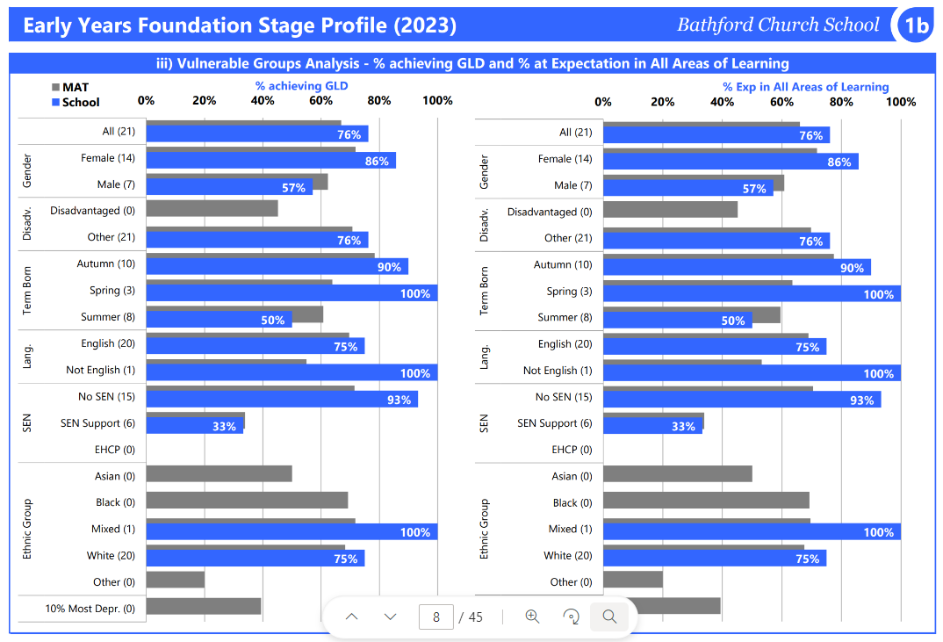
Of the 1 child identified as disadvantaged in Year 1, 1 passed the phonics screening check. 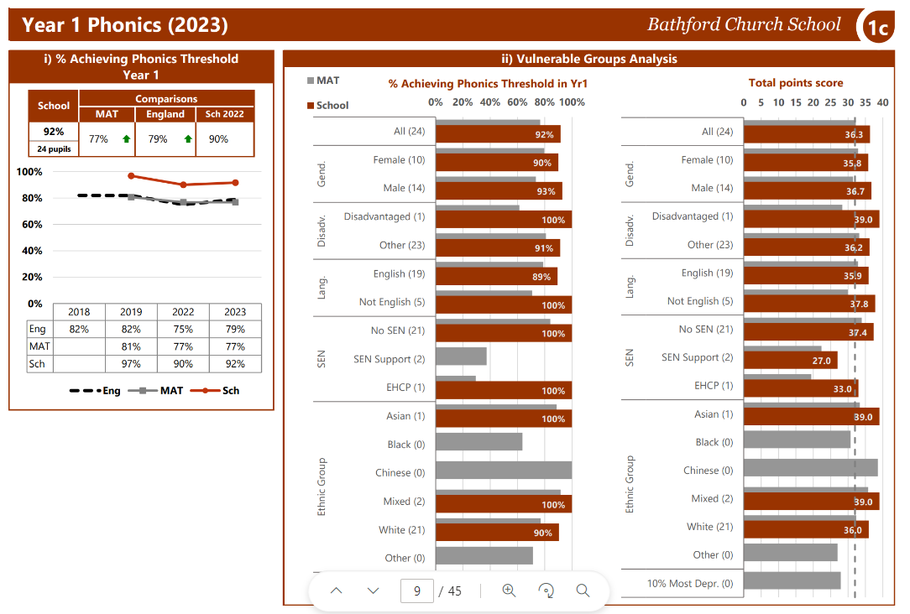
There were 2 children identified as disadvantaged in Year 2. One child met age related expectation in Reading, Writing and Mathematics:
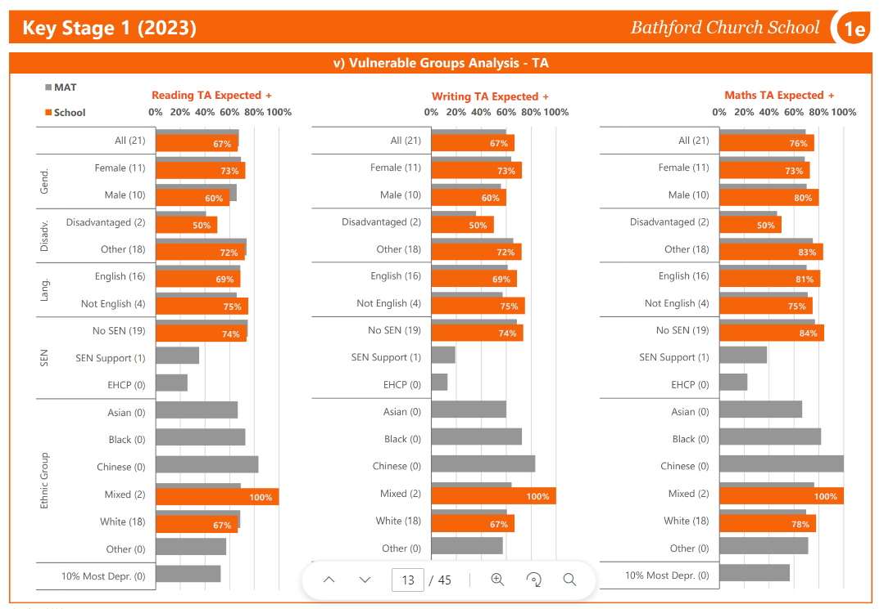
Of the 4 children identified as disadvantaged in Year 6, 2 met age related expectations for reading, writing and maths.
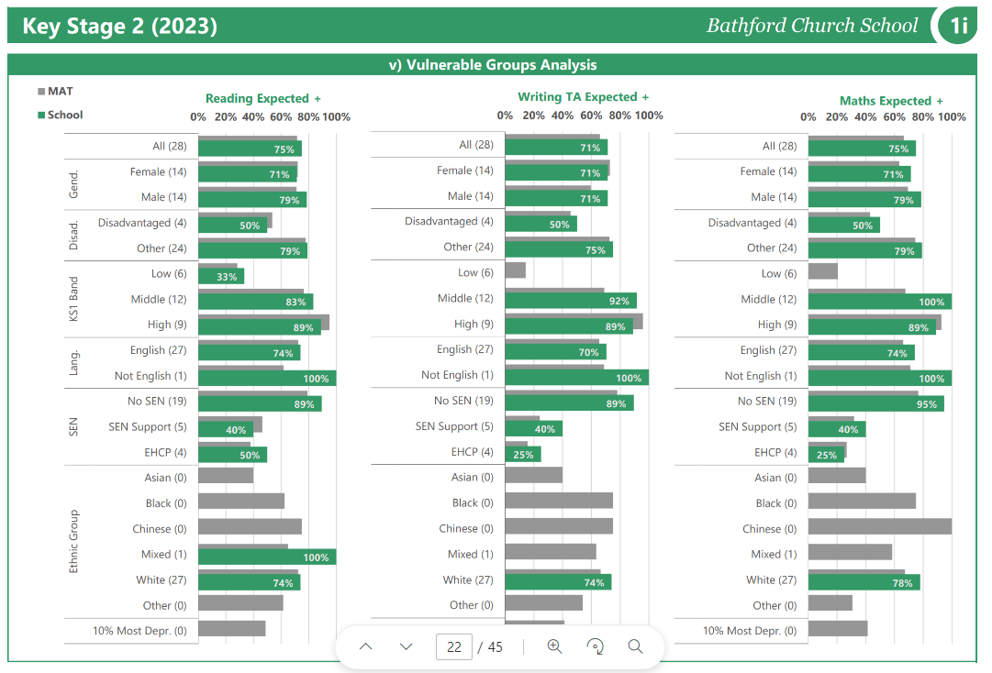

Challenge | Intended outcome | Success criteria | Evidence
1 | PP children have a positive view of themselves as learners and confidence to participate in all school activities.  PP children have access to relevant intervention/support linked to their needs, supporting emotional regulation, resilience and confidence. Provision may be internal, part of the SEND local offer or external. | - Children approach all learning with confidence and enthusiasm.  - Children have a good understanding of metacognition and their own particular learning methods.  - Children take part in a wider range of school activities.  - Identified children accessing identified support. Examples include:  - Thrive 1:1 support  - Brighter Futures  - CAMHs  - School Nurse  Parents will have an increased understanding of supportive approaches and know where to seek help.  Pupils are able to accept adult support to co-regulate or access resources to regulate independently. | SEND and CPOMs records.  Updated SEND Policy 2022  Updated School website page  Newsletter  Behaviour Policy  Additional groups, clubs and 1-1 provision.
2 | All pupil premium children will access high quality teaching of phonics and reading. Where needed this will include additional support/intervention to keep up or catch up. | - Children meeting the age-related expectation in phonics.  - Children making at least expected progress for reading.  - Pupil meet individualised learning targets (Pupil target plans). | PP Provision map  63.63% making good or above progress in reading (KS1&2).  PTPs demonstrate progress steps and provision.
3 | Children are engaged and inspired writers. Children make at least good progress in writing this academic year and have the opportunity to take pleasure in and celebrate their successes. | - Assessment identifies pupil premium children who are not meeting their potential. (Pupil voice activities, book scrutinise and planning evidence, moderation)  - Children are inspired to write for an audience and supported to write appropriately for a range of genres. | Improved writing progress data 63.63% made good or better progress.  Writing curriculum developed to promote purpose and audience.  Writing moderation completed.
4 | Families and children value good school attendance in order that pupils can access quality first teaching/full curriculum and targeted intervention where appropriate. | - Families engage positively with attendance action plans.  - Overall attendance improves for pp children.  - Persistent absenteeism reduces from pp group.  - Reduction in unauthorised absences.  - Parent involvement/communication with school increases. | Attendance has increased for PP children and averages 91.6%. There is still progress that can be made in relation to transitions into school which will be included in the 2023-24 strategy.
Review of expenditure 2022 - 2023
- Teaching
Outcomes and Impact Include impact on pupils not eligible for PP, if appropriate | Lessons learned  (and whether you will continue with this approach) | Cost
Use of provision mapping for classes was introduced and this has been positive for tracking progress in relation to whole class teaching and interventions. Teachers have received additional training to develop the use of adaptive teaching practices, metacognitive approaches and mastery opportunities for all children including those identified as PP. Impact on pupils overall positive. | We will continue this approach which helped us to effectively identify gaps and plan responsive teaching.  We will further embed this approach into our SEND practice, using the PIRA PUMA and Whiterose identified gaps to inform pupil targets. | £3000
Children identified as PP made some good progress in writing. However, as can be seen by the Years 1-6 data above, there is a gap in attainment for PP pupils who also have SEND. Although these pupils made progress, they did not make expected progress consistently across the academic year. | Looking to 2023-23, we can see that the children in 1-5 have made good progress in writing. Where this was not the case, additional SEND support will be provided by the school in collaboration with parents. The approach to phonics in particular has had a noticeable impact on the year groups who experienced the Little Wandle scheme and intervention. We will continue to use this approach.
The children are better able to make links and apply their knowledge to a broader range of learning opportunities. Teachers use subject lead key consistencies, give clear explanations, model and check frequently for understanding. Teachers give opportunity for guided practice before independent practice, provide scaffolding and make effective use of flexible grouping and technology in order to improve outcomes for children.  Teachers manage cognitive load in order to enable children to transfer new learning to long-term memory. Teachers activate prior knowledge, teach small steps and provide opportunities for children to plan, monitor and evaluate their own learning. | We will continue to embed quality first teaching in the 23/24 academic year with a focus on metacognitive strategies; including staff CPD and pupil learning opportunities. | £3000
- Targeted Academic Support
Outcomes and Impact Include impact on pupils not eligible for PP, if appropriate | Lessons learned  (and whether you will continue with this approach) | Cost
Additional attachment CPD for staff who attended sessions delivered by external providers. Attendance at each Behaviour Panel with referrals made for children identified as in need through diagnostic assessments (including Thrive assessments).  Parents/carers are seeking external advice around supporting behaviour, particularly as they feel there are reduced channels of support available that are separate to school. | The response to Thrive continues to be very positive. There continues to be an increased number of children identified by parents/teachers as requiring Thrive support. We will continue to provide staff CPD to embed whole class strategies and provide 1:1/small group support using attendance/ school transitions as one form of identification.  Sessions are scheduled for 2023-24 based on parent feedback. These will be provided by Brighter futures. | £500
Diagnostic assessments used to identify need for high quality targeted support. Interventions included speech and language sessions (external and internal), phonics interventions, reading intervention, maths intervention and dyslexia support. This will help children to build their confidence and accelerate their learning. | Diagnostic assessments have supported catch up planning and SEND support across KS1 and KS2. We will continue to use the GAP analysis capability to inform pupil target plans and closely monitor SEND pupil progress.  These diagnostic assessments have ensured greater consistency and allowed leaders (senior leaders and subject leaders) to identify, plan and implement alongside class teachers.  The phonics intervention and use of Little Wandle has had a positive impact on attainment and progress, | £4250
Weekly tutor sessions in targeted areas for PP pupils with an experienced teaching assistant and some one to one third Space learning tutoring support, in addition to standard lessons supported children to make progress. | Teachers have adopted the ‘I do, we do, you do’ approach. Where the progress of pupils in KS2 maths has not been consistent (Spring Term), additional support was put in place. Going forward we will continue to use a tutor-based approach but as one of a range of strategies to support learning. This tutor based approach will continue to be 1:1 in some cases, but in other cases it will be paired or small group tutorials in order to increase value for money.  In conjunction with this approach we will also continue to focus on quality first teaching, | £1250
- Wider Strategies
Outcomes and Impact Include impact on pupils not eligible for PP, if appropriate | Lessons learned  (and whether you will continue with this approach) | Cost
Participation in PP network. CPD on trauma informed approached informed practice and was fed into new behaviour policy. | We will continue with this approach next year | £1000
Children supported financially in order to allow participation in adventure learning and in other extra-curricular activities. This boosted self-confidence. | We will continue with this approach next year and promote opportunities directly to families to include external club providers as the offer by the school developed during 2022-23 | £1350

Externally provided programmes
Please include the names of any non-DfE programmes that you purchased in the previous academic year. This will help the Department for Education identify which ones are popular in England
Programme | Provider
Thrive | Thrive
Opal play | Opal

